Zigzag Traverse (Hard)

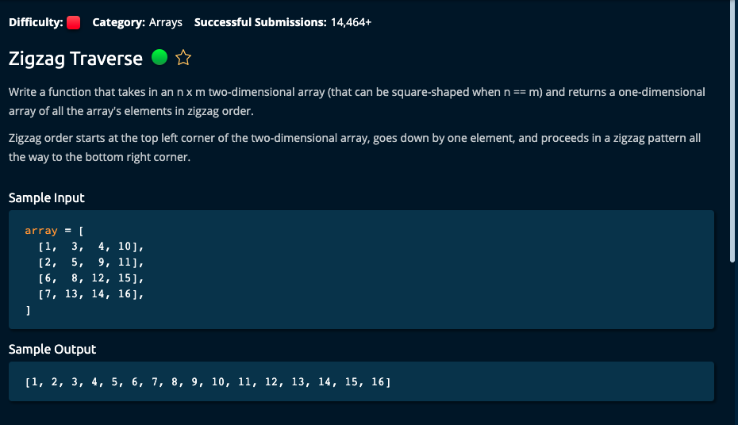

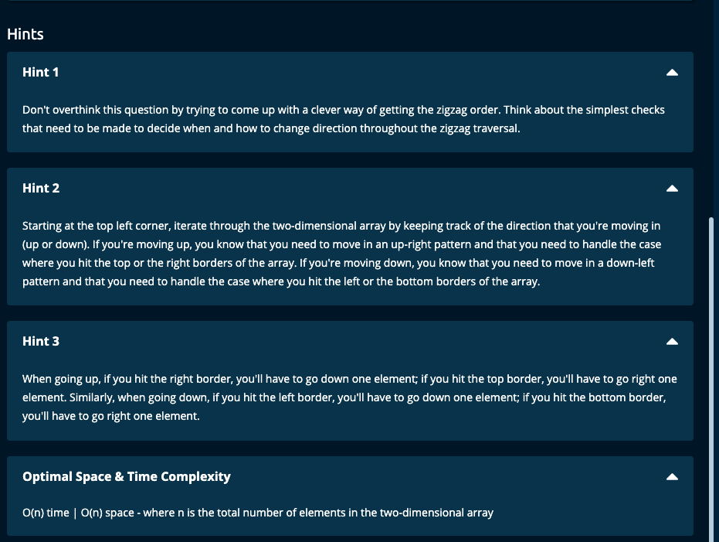

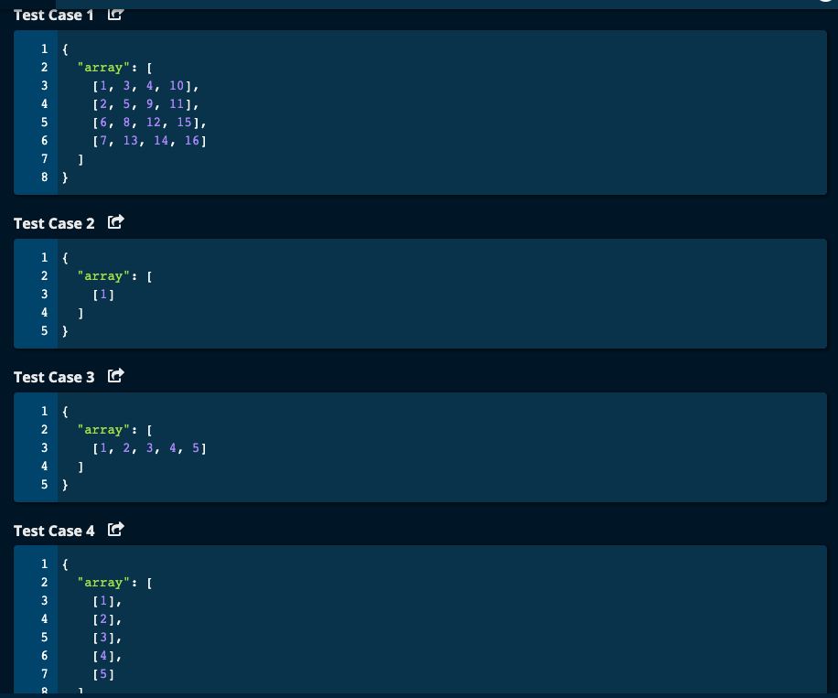

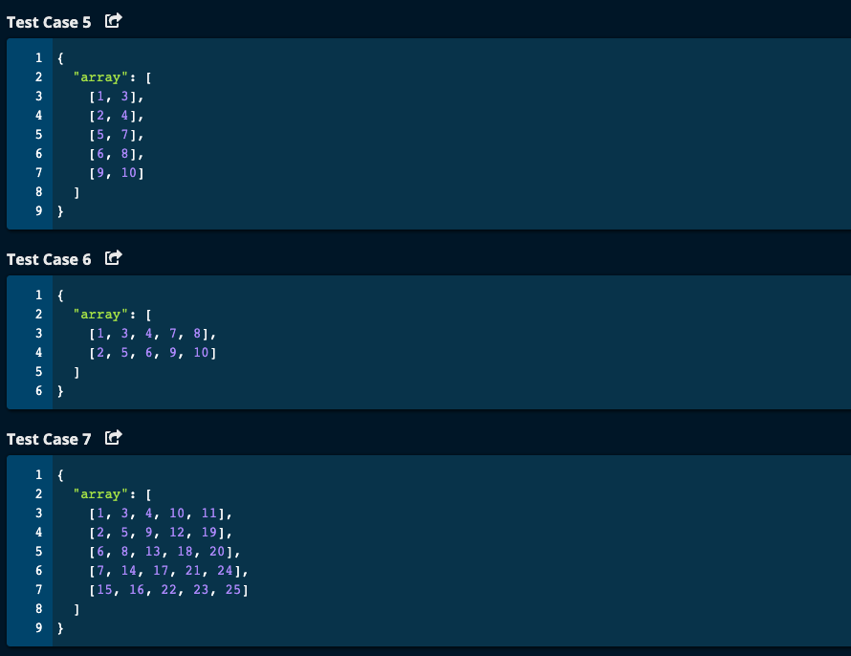

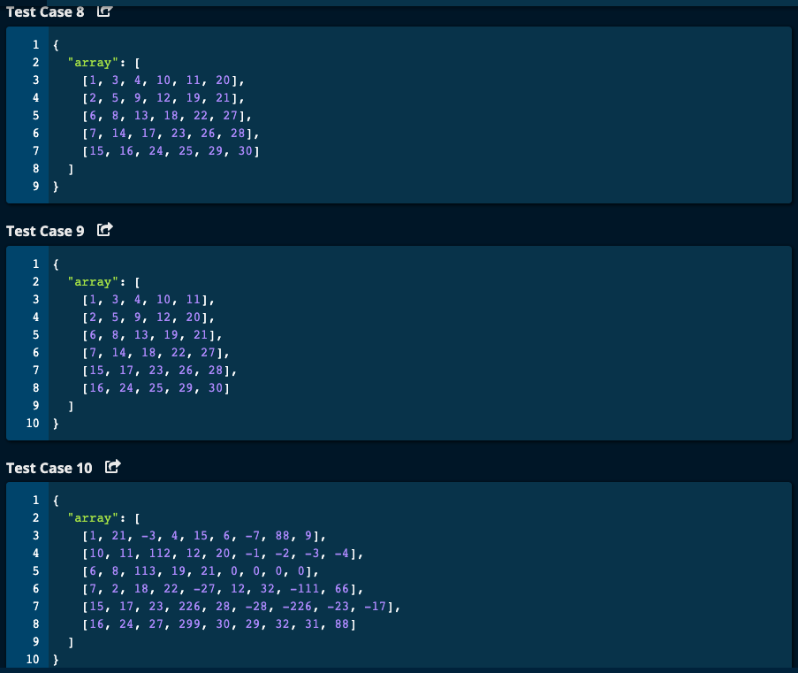

My Solution: O(n) Time | O(n) space

def zigzagTraverse(array):

result = []

row = 0

col = 0

lastRow = len(array) - 1 # last row -- (m - 1)th row

lastCol = len(array[0]) - 1 # last col -- (n - 1)th col

dir = 'down'

while row >= 0 and row <= lastRow and col >= 0 and col <= lastCol:

result.append(array[row][col])

print("Begin while -- row = ", row, "col = ", col, "result = ", result)

if dir == 'down':

if col == 0:

if row < lastRow: # go down

row += 1

# col is same

dir = 'up'

elif row == lastRow: # go right

# row is same

col += 1

dir = 'up'

else: # col <= lastCol and col > 0

if row < lastRow: # go down

row += 1

col -= 1

# dir is same

elif row == lastRow: # go right

# row is same

col += 1

dir = 'up'

else: # dir is up

if row > 0 and col < lastCol:

# dir is the same

row -= 1

col += 1

elif row == 0 and col < lastCol: # go right

# row is same

col += 1

dir = 'down'

elif row == 0 and col == lastCol:

row += 1

#col is same

dir = 'down'

elif row > 0 and row < lastRow and col == lastCol:

row += 1

#col is same

dir = 'down'

elif row == lastRow and col == lastCol:

# out condition for while loop

row += 1

col += 1

print("End while -- row = ", row, "col = ", col, "result = ", result)

return result

JJ Notes:

1. Start with direction is down and array at row 0 and col 0.
2. Go down one row and stay in the same column. Change dir to ‘up’.
3. If we hit the first column (i.e. col = 0) go down.
4. If we hit the last row, go right and change dir to up.
5. If we hit the first row other than first col go right and change dir to down.
6. If we hit the first row and last column, then change dir to down and go down one row.
7. If we are within the boundaries -- i.e. row = 0 to row = number of rows – 1, and col = 0 and number of cols – 1, if direction is up, go diagonally up, ie. Row – 1 and col + 1, and if direction is down, go diagonally down, ie., row + 1 and col – 1.
8. Finally if you reach the last spot which is row = lastRow and col = lastCol, then increment row and col so that we get out of while loop.

# Algoexpert Solution:

# Algoexpert solution -- O(n) Time | O(n) space

def zigzagTraverse(array):

height = len(array)- 1

width = len(array[0]) - 1

result = []

row, col = 0, 0

goingDown = True

while not isOutOfBounds(row, col, height, width):

result.append(array[row][col])

if goingDown:

if col == 0 or row == height:

goingDown = False

if row == height:

col += 1

else:

row += 1

else:

row += 1

col -= 1

else: # up

if row == 0 or col == width:

goingDown = True

if col == width:

row += 1

else:

col += 1

else:

row -= 1

col += 1

return result

def isOutOfBounds(row, col, height, width):

return row < 0 or row > height or col < 0 or col > width